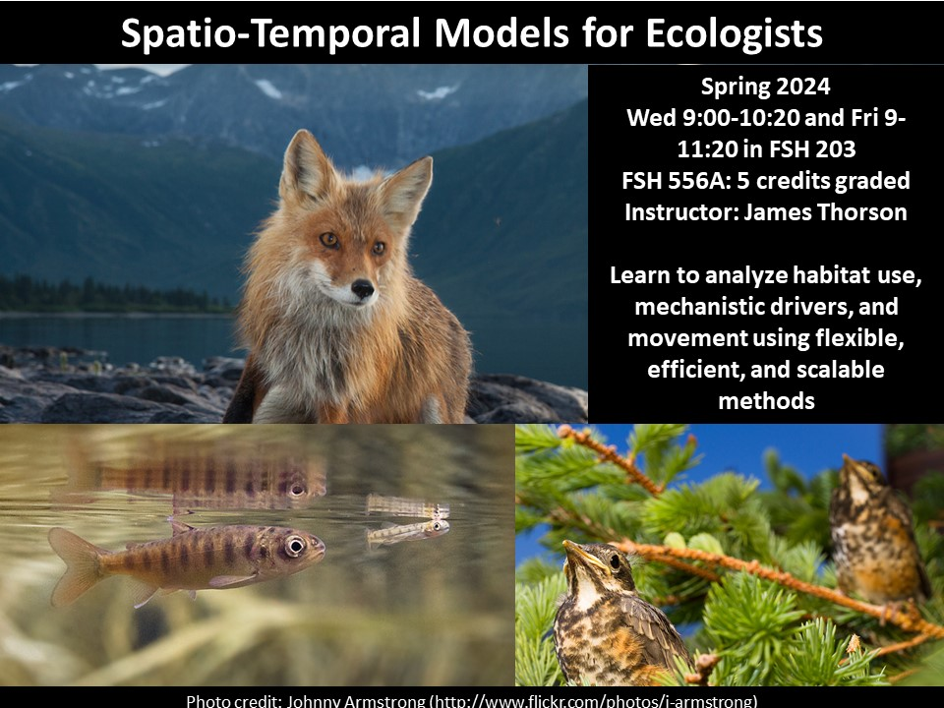

**Spatio-temporal models for ecologists**

**Instructors***:*

James Thorson

*Office Hours:*

Jim: Wed. after class

[JimThor@uw.edu](mailto:JimThor@uw.edu)

**Spring 2024 Schedule**

Wed 9:00-10:20: Lecture

Friday 9:00-11:20: Computer Lab

**Course size:** ~12 graduate students

**Credit hours:** 5

**COURSE BACKGROUND**

Ecology grew as a field to explain common spatial patterns in ecosystem structure and function. Since its birth, ecology has asked questions arising at broad spatial scales (e.g., why are some pairs of species not observed together in any island ecosystem). More recently, ecologists have developed statistical methods to separate signal (e.g., species competition in island communities) from random noise (e.g., null models for species co-occurrence). Therefore, there is continuing growth in methods and their interpretation to account for spatial patterns in both ecological processes and in unexplained noise. However, spatial statistical methods can seem intimidating without reliable tools for their development and a clear understanding of their interpretation and application.

**COURSE OBJECTIVES**

This course aims to develop applied skills for ecologists to understand, interpret, apply, and develop new models for spatial patterns in species and communities (whether marine, terrestrial, or human). In particular, students will learn to use a “mixed-effects models” which combine fixed effects (representing ecological relationships) and random effects (representing spatially structured errors). These mixed-effect models will then be used to develop models for spatial variation and how such variation can evolve over time. Students will develop these spatio-temporal models by progressively adding complexity to simple linear models. Throughout, the course will focus on a minimal toolbox to bridge between simple linear and complex spatio-temporal models. Students would be encouraged to develop an advanced understanding about the appropriate use of such approaches; namely, their correct application and their interpretation in natural sciences.

**LEARNING GOALS**

1. Apply understanding of statistical background for mixed-effects models, including statistical properties (consistency, bias, and estimating precision), when interpreting results from simulation experiments
2. Analyze spatial and spatio-temporal processes using descriptive tools including semi-variance, additive covariance functions, and separable covariance functions
3. Modify existing and create new code using R and Template Model Builder to implement linear and nonlinear mixed-effects models including spatial and temporal covariance.
4. Differentiate between the appropriate use of spatial and spatio-temporal modelling in the separation of process from spatially correlated noise.
5. Create new spatio-temporal models for use in simulation experiments, and analyze a real-world dataset of the students’ choosing.

**Pre-requisite knowledge**

We require the following experience prior to taking this class:

* Introductory knowledge of the R programming language (i.e., knowing how to open the software, save a script, perform basic arithmetic, and write a function)
  + Intro. to R programming (FISH 552), or equivalent experience
* Introductory knowledge to likelihood-based statistics (i.e., how to define a likelihood function, how to use a nonlinear optimizing function)
  + e.g., advanced R course (FISH 553), or FISH 454/458, or QSCI 451
* Intermediate background in statistical analysis (i.e., how to apply a new hierarchical model in a simulation experiment)
  + e.g., graduate-level applied analysis (FISH 558, or FISH 559, or SEFS 590), or applied statistics (STATS 516 or 517)

These skills should be acquired prior to beginning the course (i.e., students should have finished the courses above, and not be taking them concurrently). Students who are unsure whether they meet these requirements are invited to contact the instructor.

**Contacting Instructor**

Please post questions on the GitHub repository for the class in the Discussions section, so that answers to all questions can be searched and found by other students:

<https://github.com/James-Thorson/2024_FSH556/discussions>

Please only send queries that can be answered by a short message. Questions that require more in-depth responses should be made in person during office hours (see above). The Discussion tracker will be checked daily, M – F. Generally, expect a response within 24 hours after it is checked, so do not post questions the evening before a homework is due.

**Lectures and laboratories**

*Lecture format:*

Lectures are designed to ensure that students learn key theoretical concepts. Students are expected to complete readings from the course textbook prior to the Wednesday lecture. Each student will volunteer to summarize the assigned reading in a 15-min presentation at the beginning of the week’s lecture period (where the number presentations per student will depend upon the number of students in the class). This will be followed by a 15-min question-and-answer discussion led by the instructor. The instructor will then do a short presentation of a “key concept” from that weeks material. Weekly homework assignments will also be provided at the end of each lecture, and are due at the beginning of the lecture the following week.

*Lab format:*

Laboratories are designed to ensure that students learn the coding skills required to fit customized spatio-temporal models to new data. The instructor will lead a code tutorial, walking through one or more R-scripts from that week’s reading. They will then introduce the laboratory assignment, and students will work individually or in groups on that lab while the student circulates to provide help.

**Recordings and remote connection:**

All courses will be broadcasted using the URL: <https://meet.goto.com/jamestthorson/fsh556>

Lectures and labs will also be recorded, with recordings posted on YouTube at the [FishStats channel](https://www.youtube.com/channel/UCNgFcss1X9Hgox3eWSTRI3Q) after each class session. This will then permit participants who miss classes to catch up.

**Readings**

Readings are listed in the schedule below, and are taken from the class textbook “Spatio-Temporal Models for Ecologists”

**Homework**

Homework is assigned during lectures, and are due **at the beginning** of the lecture on the following week. You are required to write all code individually, even when working with assistance from other students. You are free to base code upon scripts available in the github associated with the class textbook. However, if students collaborate, they are required to each make edits to the code individually.

**Final project**

Part of the grade will be based on the final project. This grade includes:

1. a written description of the project idea due in Week 5;
2. a written project update due in Week 8;
3. a final presentation in Week 10 and finals week; and
4. a written description of the research due finals week.

The project will require either simulated or real-world application of the methods from the class (or application of the hierarchical approach using other similar methods). Students are encouraged to replicate analyses in the published literature, or find data sets using Dryad (<http://datadryad.org/>) or Ecological Archives (<http://esapubs.org/archive/search.php>).

**Grading**

Your final grade will be based on the following:

Weekly homeworks due in Weeks 2, 3, 6, and 7 (5 points each, 20 points total)

Written description of project topic and approach due in Week 5 (5 points)

Written update on the project due Week 8 (5 points)

Final presentation of project (25 points)

Written description of project (45 points)

The following lists the minimum scores needed to achieve each grade tier.

|  |  |
| --- | --- |
| **Total points** | **Grade** |
| 90+ | 4.0 |
| 80-89 | 3.5 |
| 70-79 | 3.0 |
| 60-69 | 2.5 |
| 50-59 | 2.0 |
| 40-49 | 1.5 |
| 30-39 | 1.0 |
| 20-29 | 0.7 |

Graduate students must achieve a minimum of 3.0 to receive credit towards their degree.

Late written assignments are subject to a 1 pt./day penalty and will be assigned no credit after 7 days. Presentations must be done on the day assigned, and cannot be made up. **Holidays and weekend days are NOT excluded from the late penalty assignment**.

#### [RELIGIOUS ACCOMMODATION](https://registrar.washington.edu/staffandfaculty/religious-accommodations-policy/)

Washington state law requires that UW develop a policy for accommodation of student absences or significant hardship due to reasons of faith or conscience, or for organized religious activities. The UW’s policy, including more information about how to request an accommodation, is available at [Religious Accommodations Policy (https://registrar.washington.edu/staffandfaculty/religious-accommodations-policy/).](https://registrar.washington.edu/staffandfaculty/religious-accommodations-policy/) Accommodations must be requested within the first two weeks of this course using the [Religious Accommodations Request Form (https://registrar.washington.edu/students/religious-accommodations-request/)](https://registrar.washington.edu/students/religious-accommodations-request/).

#### [DIVERSITY, EQUITY AND INCLUSION](https://environment.uw.edu/about/diversity-equity-inclusion/)

The University of Washington supports an inclusive learning environment where diverse perspectives are recognized, respected, and seen as a source of strength. In this course, I will strive to create welcoming spaces where everyone feels included and engaged regardless of their social and cultural backgrounds.

#### **DISABILITY ACCESS AND ACCOMMODATION**

It is the policy and practice of the University of Washington to create accessible learning environments consistent with federal and state law, including establishing reasonable accommodations for all students. If you have already established accommodations with Disability Resources for Students (DRS), please activate your accommodations via myDRS so that we can discuss how they will be implemented in this course.

If you have not yet established services through DRS, and you have a temporary health condition or permanent disability that requires accommodations, contact DRS directly ([disability.uw.edu](http://depts.washington.edu/uwdrs/)) to set up an Access Plan. DRS facilitates the interactive process that establishes reasonable accommodations.  Conditions requiring accommodation include but are not limited to: mental health, attention-related, learning, vision, hearing, physical or health impacts.

In assessing whether you require reasonable accommodations through DRS, please note that full participation in this course requires the following types of engagement: [to be described by the instructor. See example [here](https://environment.uw.edu/intranet/academics/teaching/sample-syllabus-disability-statement/).]

#### [**ACADEMIC INTEGRITY**](https://environment.uw.edu/intranet/academics/academic-integrity/)

The University of Washington Student Conduct Code ([WAC 478-121](http://www.washington.edu/admin/rules/policies/WAC/478-121TOC.html)) defines prohibited academic and behavioral conduct and describes how the University holds students accountable. I expect that you will know and follow university policies regarding all forms of academic and other misconduct.

Acts of academic misconduct include:

* Cheating:
  + - unauthorized assistance in person and/or online for assignments, quizzes, tests or exams
    - using another student’s work without permission and instructor authorization
    - allowing anyone to take a course, assignment or exam for you without instructor authorization
* Falsification: intentional use of falsified data, information or records
* Plagiarism: representing the work of others as your own without giving appropriate credit to the original author(s)
* Unauthorized collaboration: working with other students in the course on assignments, quizzes or exams without permission
* Engaging in behavior prohibited by an instructor
* Multiple submissions of the same work in different courses without instructor permission
* Deliberately damaging or destroying student work to gain advantage
* Unauthorized recording, and/or subsequent dissemination of instructional content

If these definitions are not clear to you, please contact me or your TAs so that we can review them with you.  It is important that you fully understand what is and is not permissible in this course.

Any suspected cases of academic misconduct will be handled according to university regulations, which include:

1. submission of the case material (description of the incident and supporting documents such as an exam, paper, and any communications about the incident) to the College of the Environment Dean’s Office
2. suspension of the grade for the quiz, exam, homework, paper or other assignment in question
3. an F grade for the class in the case of the academic misconduct procedure continuing past the end of the quarter
4. a reduction, down to a zero, for the quiz, exam, homework, paper or other assignment in question should the academic misconduct hearing officer find you responsible

For more information, see the College of the Environment’s [Academic Misconduct Policy](https://environment.uw.edu/intranet/academics/academic-policies/academic-misconduct/) and the [Community Standards and Student Conduct](https://www.washington.edu/cssc/) website.

The College of the Environment[Student Academic Grievance Procedures](https://environment.uw.edu/intranet/academics/academic-policies/student-academic-grievance-procedures/) provide mechanisms for enrolled students to address academic problems or grievances in an equitable, respectful and timely manner. Academic grievances are defined as those involving conflicts between a student or students and their course instructors (including faculty and teaching assistants) or research mentor(s) with respect to differences arising within credit-bearing work and while the student is registered at the University of Washington.  If you have or are experiencing such a conflict in this class, and have not, cannot, or do not wish to attempt resolution with me, I encourage you to explore additional options open to you by accessing the website above.

**ABSENCE POLICY**

***Excused absences:*** Our attendance and participation policies are flexible only under specific circumstances. Excused absences are religious holidays, pre-approved professional activities, and injury or illness of a student or immediate family member. Notification of anticipated absences are required by the end of the second week of class.

**MISSED EXAM POLICY**

If you have a legitimate emergency, please contact the instructor no later than one hour before the start of the exam. Failure to prove adequate notification will result in a zero for the exam.

#### [SAFETY](https://www.washington.edu/safecampus/)

If you feel unsafe or at-risk while taking this or any course, please contact [SafeCampus](http://if%20you%20feel%20unsafe%20or%20at-risk%20while%20taking%20this%20or%20any%20course,%20please/" \t "_blank), 206-685-7233 anytime where you can anonymously discuss safety and well-being concerns for yourself or others. SafeCampus can provide individualized support, discuss short- and long-term solutions, and connect you with additional resources when requested.  For a broader range of resources and assistance see the [Husky Health & Well-Being](https://wellbeing.uw.edu/) website.

#### **ARTIFICIAL INTELLIGENCE (AI)**

In this class, the use of AI applications such as ChatGPT or Dolly to produce the first draft of any assignment, or the answer to any quiz or exam question will be considered plagiarism (using the work and/or ideas of others as your own and without attribution).  Using an AI tool to produce needed text and then altering that text with slightly different wording (paraphrasing) is still plagiarism.

### Academic Conduct Statement

At the University level, passing anyone else’s scholarly work (which can include written material, exam answers, graphics or other images, and even ideas) as your own, without proper attribution, is considered academic misconduct.

Plagiarism, cheating, and other misconduct are serious violations of the [University of Washington Student Conduct Code (WAC 478‐120)](http://www.washington.edu/students/handbook/conduct.html). We expect that you will know and follow university policies on cheating and plagiarism. Any suspected cases of academic misconduct will be handled according to university regulations. For more information, see the College of the Environment’s [Academic Misconduct Policy](http://environment.uw.edu/intranet/academics/academic-policies/academic-misconduct/) and the [Community Standards and Student Conduct website](http://www.washington.edu/cssc/).

**Draft syllabus**

|  |  |  |  |  |  |  |  |
| --- | --- | --- | --- | --- | --- | --- | --- |
| Week | Session | Subject | Assigned reading (to be done before class) | Homework assigned | Homework due | Student presentation topic (15 min) | Volunteer |
| 1 (March 25) | Lecture | Stochastic processes and Generalized Linear models | Chap-1 | HW1 |  | NA | NA |
|  | Lab | Generalized linear mixed models | Chap-2 |  |  | NA | NA |
| 2 (April 1) | Lecture | Univariate state-space models | Chap-3 | HW2 | HW1 | Chap-3 core ideas |  |
|  | Lab | “ |  |  |  | NA |  |
| 3 (April 8) | Lecture | Multivariate state-space models | Chap-4 | Project idea | HW2 | Chap-4 core ideas |  |
|  | Lab | “ |  |  |  | NA |  |
| 4 (April 15) | Lecture | NO CLASS |  |  |  |  |  |
|  | Lab | NO CLASS |  |  |  |  |  |
| 5 (April 22) | Lecture | Spatial models | Chap-5 | HW3 | Project idea | Chap-5 core ideas |  |
|  | Lab | “ |  |  |  | NA |  |
| 6 (April 29) | Lecture | Sampling designs | Chap-6 | HW4 | HW3 | Chap-6 core ideas |  |
|  | Lab | “ |  |  |  | NA |  |
| 7 (May 6) | Lecture | Covariates | Chap-7 | Written project update | HW4 | Chap-7 core ideas |  |
|  | Lab | “ |  |  |  | NA |  |
| 8 (May 13) | Lecture | Spatio-temporal models | Chap-8 | Final project | Written project update | Chap-8 core ideas |  |
|  | Lab | Teleconnections | Chap-9 |  |  | Chap-9 core ideas |  |
| 9 (May 20) | Lecture | Eulerian movement | Chap-10 |  |  | Chap-10 core ideas |  |
|  | Lab | “ |  |  |  | NA |  |
| 10 (May 27) | Lecture | Multivariate spatial models | Chap-11 |  |  | Chap-11 core ideas |  |
|  | Lab | “ |  |  |  | NA |  |
| Finals | TBD | Presentations |  |  | Projects | NA | NA |